SQL Server Automated Installation via PowerShell#
Outcome#
The purpose of this procedure is to automate MS-SQL Database Server installation in Council's Infrastructure.
- This procedure is required to be performed when:
  - Installation of SQL Server Database Instance on Newly Built VM.
  - Installation of SQL Server Database Instance on an existing VM.
SQL Server Automated Installation has been devised in order to achieve a common standard across all of the deployments. This procedure can be performed during business hours for new deployments and post business hours only if new instance is to be added to existing VMs
This procedure is strictly limited for Deployment of SQL Server on existing/new VMs

Prerequisites#
The following are prerequisites for the successful completion of this procedure:
- Normal Change within ITSM7 with appropriate notes, design documents, capacity approvals attached to the change. These changes are raised by the Database Duty Desk.

Actions#
- The following actions are encompassed within this Normal change.
  - Start SQL Server Installation via PowerShell using the Attached Guide or proceed as below.
  - RDP to your Target Server and head over to path E:\Stage\PowerShellConfigFiles.
  - 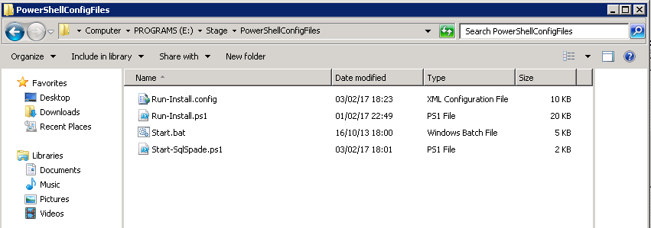
  - Verify if E:\Audit and E:\Backup folders exist. E:\Backup should also have DBA_Maintenance_2014.bak file in it
  - 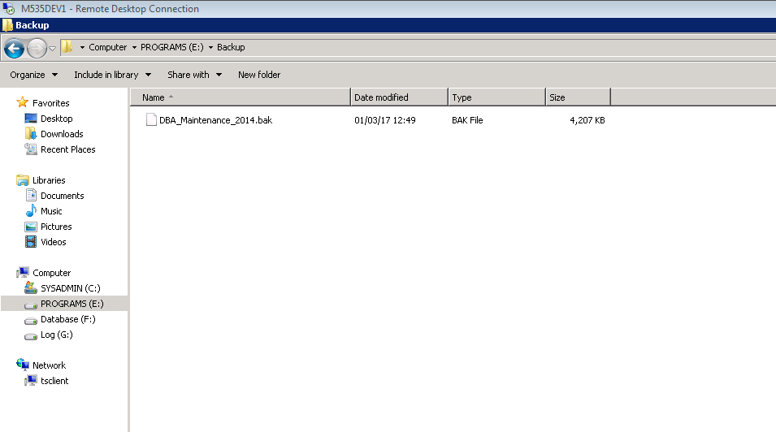
  - Go to E:\Stage\SQLInstallPowerShell and verify if it exists
  - 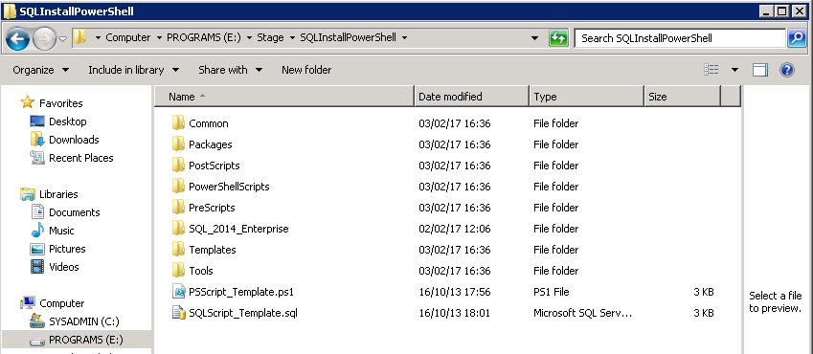
  - Now, go back to PowerShellConfigFiles folder and open the “Run-Install.config” and edit the Overrides as explained in the comments next to the Parameters. A template is attached here for reference
  - 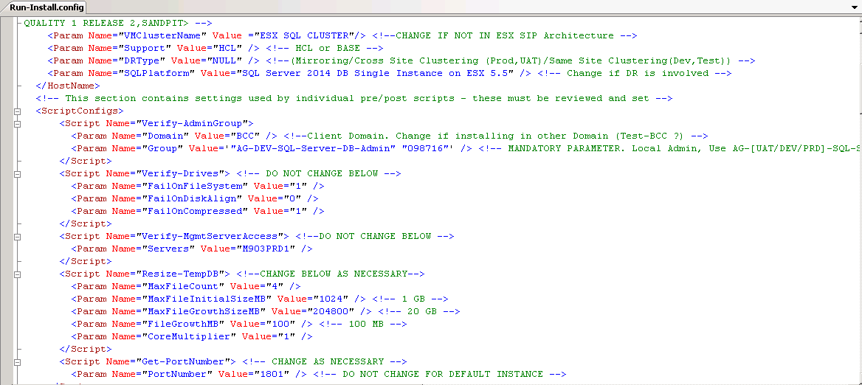
  - Save the Changes and run the Start.bat as Administrator.
  - 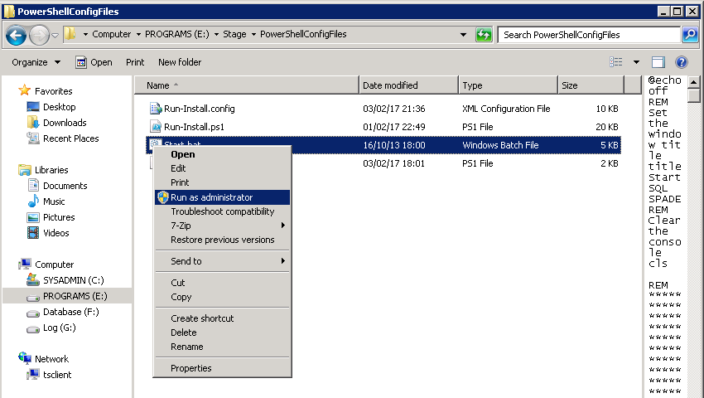
  - Start.bat file invokes the PowerShell File on which the final overrides are to be placed before the installation can begin. Again, edit the Parameters as explained in the comments next to them.
  - 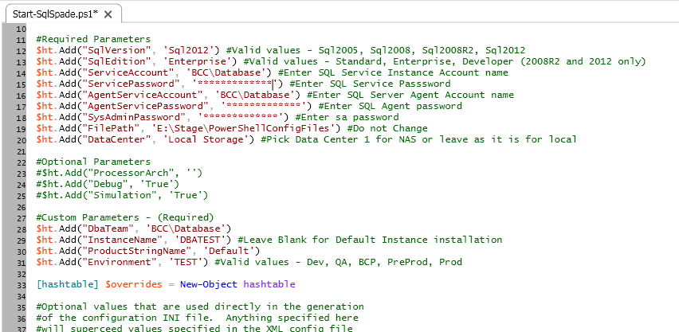
  - After filling the required parameters, execute the PowerShell script and it will trigger SQL installation procedure as in the below screen
  - 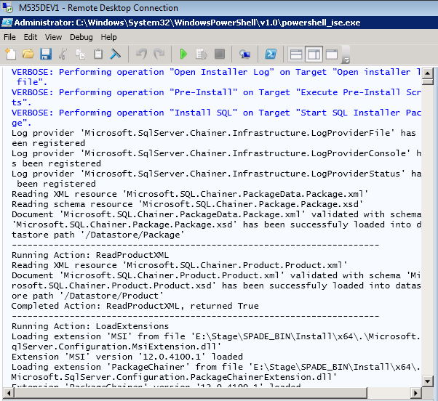
  - Minimize the below IE window.
  - 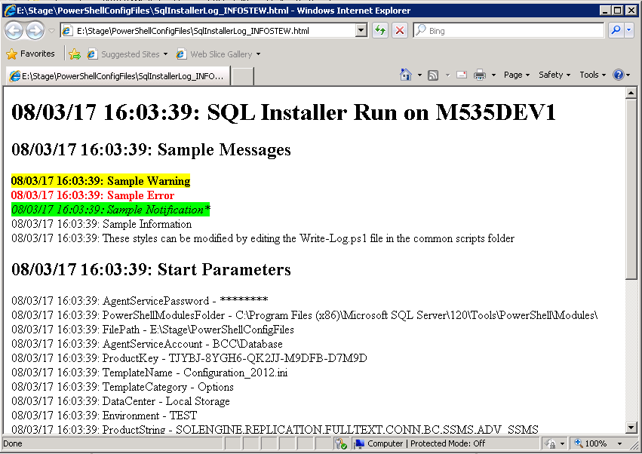
NOTE: For SQL 2016, install SSMS.#

  - Connect to SSMS, Go to System Databases, go to Master and Revoke _View Definition_ and _View ANy Database_ permission if any
http://supportdocs1.bcc.qld.gov.au:8080/wiki_db/Wiki.jsp?page=SQLServerPostInstallationSetup#section-SQLServerPostInstallationSetup-RevokeViewAnyDatabase http://supportdocs1.bcc.qld.gov.au:8080/wiki_db/Wiki.jsp?page=SQLServerPostInstallationSetup#section-SQLServerPostInstallationSetup-RevokeViewDefinition

  - Configure SQL Server Services for Delayed AutoStart (Mandatory, Only for Servers with No Clustering)
On Run Type Services.msc and go to SQL Server Service and rigt click and open properties, In General Tab Select Startup Type Automatic (Delay Start) then click on OK

  - Install Data Domain Client by following procedure
  - http://supportdocs1.bcc.qld.gov.au:8080/wiki_db/Wiki.jsp?page=SQL%20Server%20Database%20DDBOOST%20Installation%20Procedure%20%28Generic%29
  - Deploy DBA_Mantenance SSIS package from M903PRD1(integration services) to Target Server
http://supportdocs1.bcc.qld.gov.au:8080/wiki_db/attach/SQL%20Server%20Automated%20Installation%20via%20PowerShell/Deployment%20of%20DBA_MaintenancePlan%20to%20Target%20Server.doc

  - Configure Backup Purging Job using http://supportdocs1.bcc.qld.gov.au:8080/wiki_db/Wiki.jsp?page=Purging%20of%20Expired%20Backup%20Sets%20from%20DataDomain%20using%20DDBOOST
  - Enable Lock Page in Memory and Instant File Initialisation
    - On the Start menu, click Run. In the Open box, type gpedit.msc
    - On the Local Group Policy Editor console, expand Computer Configuration, and then expand Windows Settings
    - Expand Security Settings, and then expand Local Policies
    - Select the User Rights Assignment folder
    - In the Local Security Setting – Lock pages in memory dialog box, click Add User or Group.
    - In the Select Users, Service Accounts, or Groups dialog box, add an account with privileges to run sqlservr.exe.
    - In the Local Security Setting –Perform volume maintenance tasks,click Add User or Group.
    - In the Select Users, Service Accounts, or Groups dialog box, add an account with privileges to run sqlservr.exe.
    - Log out and then log back or reboot in for this change to take effect.
  - Configure SSL encryption follow http://supportdocs1.bcc.qld.gov.au:8080/wiki_db/Wiki.jsp?page=SSL%20encryption%20on%20SQL%20Server%20instance%20by%20using%20Microsoft%20Management%20Console%20Procedure%20%28Generic%29
  - Configure TDE Encryption This encryption will help us to encrypt the database. Follow the below link to encrypt database:
http://supportdocs1.bcc.qld.gov.au:8080/wiki_db/Wiki.jsp?page=Transparent%20Data%20Encryption%20%28TDE%29%20in%20SQL%20Server-Procedure%28Generic%29

  - Verify SAC policies inside PBM and Use PBM to periodically evaluate policies
http://supportdocs1.bcc.qld.gov.au:8080/wiki_db/Wiki.jsp?page=Surface%20Area%20Configuration%20for%20SQL%20Server%20Procedure%28Generic%29

Restore DBA_Maintenance Database (Mandatory)#

Note:Backups of the latest DBA_Maintenance Database can be found in E:\Backup on the target Database server
provided the template, W2K8-x64-R2-ENT-MSSQL, has been used to create the server.
- An example procedure using SSMS 2008 for restoring the DBA_Maintenance database can be found here.
- An example procedure using SSMS 2012 for restoring the DBA_Maintenance database can be found here
Note: If the server was not created using the template, W2K8-x64-R2-ENT-MSSQL, a copy of the latest backup of the DBA_Maintenance database can be found here.
- Ensure the collation method for the DBA_Maintenance database is the same as the sql server instance.
SELECT SERVERPROPERTY('COLLATION')
GO
SELECT DATABASEPROPERTYEX('DBA_MAINTENANCE','COLLATION')
GO
--If [DBA_Maintenance] Database Collation is different from Server Collation alter the collation with the following command
USE [master]
GO
ALTER DATABASE [DBA_Maintenance] COLLATE <SQL SERVER INSTANCE COLLATION METHOD>
GO

eg:
USE [master]
GO
ALTER DATABASE [DBA_Maintenance] COLLATE Latin1_General_CI_AS
GO

Revoke View Any Database #
- Open system database, click on permissions and then go to server permissions.
- Uncheck View any database

Revoke View Definition#
- Open database, click on permissions.
- Uncheck View Definition.

Set the Initial size and Autogrowth Setting of the Database#
USE [master]
GO
ALTER DATABASE [master] MODIFY FILE ( NAME = N'master', SIZE = 64MB , FILEGROWTH = 16MB )
GO
ALTER DATABASE [master] MODIFY FILE ( NAME = N'mastlog', SIZE = 16MB , FILEGROWTH = 16MB )
GO

USE [master]
GO
ALTER DATABASE [msdb] MODIFY FILE ( NAME = N'MSDBData', SIZE = 256MB , FILEGROWTH = 64MB )
GO
ALTER DATABASE [msdb] MODIFY FILE ( NAME = N'MSDBLog', SIZE = 64MB , FILEGROWTH = 32MB )
GO

USE [master]
GO
ALTER DATABASE [model] MODIFY FILE ( NAME = N'modeldev', SIZE = 256MB , FILEGROWTH = 64MB )
GO
ALTER DATABASE [model] MODIFY FILE ( NAME = N'modellog', SIZE = 64MB , FILEGROWTH = 32MB )
GO
Verify Autogrowth settings#
SELECT
S.[name] AS [Logical Name]
,S.[file_id] AS [File ID]
, S.[physical_name] AS [File Name]
--,CAST(CAST(G.name AS VARBINARY(256)) AS sysname) AS [FileGroup_Name]
,CONVERT (varchar(10),(S.[size]*8)) + ' KB' AS [Size]
,CASE WHEN S.[max_size]=-1 THEN 'Unlimited' ELSE CONVERT(VARCHAR(10),CONVERT(bigint,S.[max_size])*8) +' KB' END AS [Max Size]
,CASE s.is_percent_growth WHEN 1 THEN CONVERT(VARCHAR(10),S.growth) +'%' ELSE Convert(VARCHAR(10),S.growth*8) +' KB' END AS [Growth]
,Case WHEN S.[type]=0 THEN 'Data Only'
WHEN S.[type]=1 THEN 'Log Only'
WHEN S.[type]=2 THEN 'FILESTREAM Only'
WHEN S.[type]=3 THEN 'Informational purposes Only'
WHEN S.[type]=4 THEN 'Full-text '
END AS [usage]
,DB_name(S.database_id) AS [Database Name]
FROM sys.master_files AS S where S.[name] in ('master','modeldev','MSDBData','MSDBLog','mastlog')

Move the System Databases#
Need to move only log file for master,model,msdb To move a system database data or log file follow these steps. This procedure applies to all system databases except the master and Resource databases.
- For each file to be moved, run the following statement.
ALTER DATABASE database_name MODIFY FILE ( NAME = logical_name , FILENAME = 'new_path\os_file_name' );
- Verify the file change by running the following query.
SELECT name, physical_name AS CurrentLocation, state_desc
FROM sys.master_files
WHERE database_id = DB_ID(N'<database_name>');
- Stop the instance of SQL Server
- Move the file or files to the new location
- Restart the instance of SQL Server or the server
- Verify that Service Broker is enabled for the msdb database by running the following query.
SELECT is_broker_enabled
FROM sys.databases
WHERE name = N'msdb';
- Verify that Database Mail is working by sending a test mail.
- To move the master database click SQL Server Configuration Manager.
- In the SQL Server Services node, right-click the instance of SQL Server (for example, SQL Server (MSSQLSERVER)) and choose Properties.
- In the SQL Server (instance_name) Properties dialog box, click the Advanced tab.
- Edit the Startup Parameters values to point to the planned location for the master database log files, and click OK. The parameter value for the data file must follow the -d parameter and the value for the log file must follow the -l parameter.
- Stop the instance of SQL Server by right-clicking the instance name and choosing Stop.
- Move the mastlog.ldf files to the new location.
- Restart the instance of SQL Server.
- Verify the file change for the master database by running the following query.
SELECT name, physical_name AS CurrentLocation, state_desc
FROM sys.master_files
WHERE database_id = DB_ID('master');
- To move the tempdb determine the logical file names of the tempdb database and their current location on the disk.
SELECT name, physical_name AS CurrentLocation
FROM sys.master_files
WHERE database_id = DB_ID(N'tempdb');
GO
- Change the location of each file by using ALTER DATABASE.
USE master;
GO
ALTER DATABASE tempdb
MODIFY FILE (NAME = tempdev, FILENAME = 'new_path\os_file_name');
GO
ALTER DATABASE tempdb
MODIFY FILE (NAME = templog, FILENAME = 'new_path\os_file_name');
GO
- Stop and restart the instance of SQL Server.
- Verify the file change.
SELECT name, physical_name AS CurrentLocation, state_desc
FROM sys.master_files
WHERE database_id = DB_ID(N'tempdb');
- Delete the tempdb.mdf and templog.ldf files from the original location.
Configure VM Guest#
Configure SQL Server Services for Delayed AutoStart (Mandatory, Only for Servers with No Clustering)#
- The SQL Server implementations used within this site rely on service accounts that are defined to the BCC Domain.
All 2008 Virtual Machine implementations suffer from premature starting of the SQL Server Instances prior to being able
to contact the BCC Domain Controller. This results in the services not restarting after a reboot.
To remedy this the ffollowing services should be set to Automatic (Delayed Start) for Default Instances:
Note: This is not required for the SQL Agent as it has a dependency on SQL Server service.

  - SQL Server (MSSQLSERVER)
  - SQL Server Analysis Services (MSSQLSERVER)
- For named instances the following services should be set to Automatic (Delayed Start):
Note: This is not required for the SQL Agent as it has a dependency on SQL Server service.

  - SQL Server (<Named Instance>)
  - SQL Server Analysis Services (<Named Instance>)
- An example procedure to do this can be found here.
Configure Loop Back Check#
Note: The DisableLoopbackCheck configuration below is only required if the server has NOT been created with the template, W2K8-x64-R2-ENT-MSSQL.
- Ensure the DisableLoopbackCheck registry entry to 1. If this is not set then use the procedure below:
  - Click Start, click Run, type regedit, and then click OK.
  - Locate and then click the following registry subkey: HKEY_LOCAL_MACHINE\SYSTEM\CurrentControlSet\Control\Lsa
  - Right-click Lsa, point to New, and then click DWORD Value.
  - Type DisableLoopbackCheck, and then press ENTER.
  - Right-click DisableLoopbackCheck, and then click Modify.
  - In the Value data box, type 1, and then click OK.
  - Exit Registry Editor.
  - Restart the computer.
Enable Lock Pages Memory#
- On the Start menu, click Run. In the Open box, type gpedit.msc.
- On the Local Group Policy Editor console, expand Computer Configuration, and then expand Windows Settings.
- Expand Security Settings, and then expand Local Policies.
- Select the User Rights Assignment folder.
The policies will be displayed in the details pane.
- In the Local Security Setting – Lock pages in memory dialog box, click Add User or Group.
- In the Select Users, Service Accounts, or Groups dialog box, add an account with privileges to run sqlservr.exe.
- Log out and then log back or reboot in for this change to take effect.

Setup Database Mail (Mandatory)#
- This can be configured through the following activities:
  - Enable the Mail Feature, Create Public SMTP Profile, Allocate a Standard SMTP Account
  - Create a Database Operator, DDDatabase Script
  - Configure the SQL Agent Alerting System to alert to this Operator
- An example of a SMTP mail configuration in a secure environment to the
DDDatabase Account can be found here

Install Backup Infrastructure#
Note: For Clustered Installations the following Networker Module will need to be installed on both nodes in the Cluster.
- Install Database Backup Jobs (Mandatory)
Note: For Clustered Installations the following will also need to be done
- Add a Credential for the BCC\database account:
/*
Replace <PASSWORD> with the password for the BCC\database account found in the Portal
*/
USE [master]
GO
CREATE CREDENTIAL [Database] WITH IDENTITY = N'BCC\database', SECRET = N'<PASSWORD>'
GO
- Add a Proxy for the Database credential
USE [msdb]
GO
/****** Object: ProxyAccount [Database] Script Date: 06/14/2013 12:28:30 ******/
EXEC msdb.dbo.sp_add_proxy @proxy_name=N'Database',@credential_name=N'Database', @enabled=1
GO
EXEC msdb.dbo.sp_grant_proxy_to_subsystem @proxy_name=N'Database', @subsystem_id=3
GO
- For the two Database To Tape backups jobs, change the Run As to the Proxy
USE [msdb]
GO
EXEC msdb.dbo.sp_update_jobstep @job_name=N'Database To Tape - Full Backup', @step_id=1 , @proxy_name=N'Database'
GO
USE [msdb]
GO
EXEC msdb.dbo.sp_update_jobstep @job_name=N'Database To Tape - Transaction Log Backup', @step_id=1 , @proxy_name=N'Database'
GO
- Add the SQL Agent service account to the local Administrators group on both Nodes of the Cluster.
- Restart the SQL Agent service using the Failover Cluster Manager

Backup Purging job#
Configure Backup Purging job using : Follow ---_Note: For Clustered Installations the following software will need to be installed on both nodes in the Cluster.

Exclude Databases using Simple Recovery Model from Transaction Log Backups that use the nsrsqlsv.exe utility (Mandatory)#
- The nsqsqlsv.exe backup utility performs a Full Backup instead of a Transaction Log Backup when the database is using the Simple Recovery Model.
There are a number of databases using the Simple Recovery Model including master, msdb and DBA_Maintenance.
These need to be excluded from the Transaction Log Backup job that uses the nsqsqlsv.exe utlity.
The job name is Database To Tape - Transaction Log Backup.
Edit the Step that is performing the backup.
An example of a backup command that excludes the msdb, master and DBA_Maintenance databases is as follows:
  - nsrsqlsv -s bkup2 -c m460trn1 -h msdb -h master -h DBA_Maintenance -g BSQDatabase -v -l incr MSSQL:

Install DataDomain Client#
Install DD client using : Link

Exclude Database Directories from Server Side Backups (Optional)#
Note: This is only required if the Centralised MSSQL Directive has NOT been configured against the Networker Client.
- For SQL Server 2008
  - In order to prevent directories or files being backed up uneccessarily nsr.dir files need to be placed on the database server. You can copy the nsr.dir file from E:\Stage\nsr.dir
An example of the contents of a nsr.dir file that is placed in the directory F:\MSSQL10_50.SP01\MSSQL\DATA is detailed below:
<<"F:\MSSQL10_50.SP01\MSSQL\DATA">>

skip: *

  - The nsr.dir files must be placed in the following directories:
    - Database Data Directory eg. F:\MSSQL10_50.SP01\MSSQL\DATA
    - Database Transaction Log Directory eg: G:\MSSQL10_50.SP01\MSSQL\DATA
    - Local Disk Backup Directory eg: F:\MSSQL10_50.SP01\MSSQL\BACKUP
    - Staging directory eg E:\stage
    - Adhoc Backup Directory eg: E:\Backup
    - Temp Direcoty E:\temp
- For SQL Server 2012
  - In order to prevent directories or files being backed up uneccessarily nsr.dir files need to be placed on the database server. An example of the contents of a nsr.dir file that is placed in the directory F:\MSSQL11.SP01\MSSQL\DATA is detailed below:
<<"F:\MSSQL11.SP01\MSSQL\DATA">>

skip: *

  - The nsr.dir files must be placed in the following directories:
    - Database Data Directory eg. F:\MSSQL11.SP01\MSSQL\DATA
    - Database Transaction Log Directory eg: G:\MSSQL11.SP01\MSSQL\DATA
    - Local Disk Backup Directory eg: F:\MSSQL11.SP01\MSSQL\BACKUP
    - Staging directory eg E:\stage
    - Adhoc Backup Directory eg: E:\Backup
    - Temp Direcoty E:\temp

Configure Maintenance Infrastructure#
Determine the Backup Strategy to be used.#
Deploy DBA_Maintenance_Plan to Target Server#
Create Local Directories for Disk Backup Storage#
When installed the SQL Server will have a server property set up for a default database backup directory. This can be obtained by querying the registry using REGEDIT and navigate to this key:
- For SQL Server 2008:
  - Default Instance:
    - HKEY_LOCAL_MACHINE\SOFTWARE\Microsoft\Microsoft SQL Server\MSSQL10_50.MSSQLSERVER\MSSQLServer\BackupDirectory
  - Named Instance:
    - HKEY_LOCAL_MACHINE\SOFTWARE\Microsoft\Microsoft SQL Server\MSSQL10_50.<INSTANCE_NAME>\MSSQLServer\BackupDirectory
- For SQL Server 2012:
  - Default Instance:
    - HKEY_LOCAL_MACHINE\SOFTWARE\Microsoft\Microsoft SQL Server\MSSQL11.MSSQLSERVER\MSSQLServer\BackupDirectory
  - Named Instance:
    - HKEY_LOCAL_MACHINE\SOFTWARE\Microsoft\Microsoft SQL Server\MSSQL11.<INSTANCE_NAME>\MSSQLServer\BackupDirectory
You could also execute the following query. The value in the Data column is the default backup location.
- For SQL Server 2008:
  - Default Instance:
EXECUTE master.dbo.xp_regread 'HKEY_LOCAL_MACHINE','SOFTWARE\Microsoft\Microsoft SQL Server\MSSQL10_50.MSSQLSERVER\MSSQLServer','BackupDirectory'

  - Named Instance:
EXECUTE master.dbo.xp_regread 'HKEY_LOCAL_MACHINE','SOFTWARE\Microsoft\Microsoft SQL Server\MSSQL10_50.<INSTANCE_NAME>\MSSQLServer','BackupDirectory'
- For SQL Server 2012:
  - Default Instance:
EXECUTE master.dbo.xp_regread 'HKEY_LOCAL_MACHINE','SOFTWARE\Microsoft\Microsoft SQL Server\MSSQL11.MSSQLSERVER\MSSQLServer','BackupDirectory'

  - Named Instance:
EXECUTE master.dbo.xp_regread 'HKEY_LOCAL_MACHINE','SOFTWARE\Microsoft\Microsoft SQL Server\MSSQL11.<INSTANCE_NAME>\MSSQLServer','BackupDirectory'
Once you know the default Backup Directory. Navigate to the default directory and create the following directories
mkdir TransactionLog
mkdir Full
mkdir MasterKey
Schedule Backups, Weekly and Daily Maintenance #
Note: When editing Maintenance Plans, always use the Management Studio on the server where the Maintenance Plan will run.
- Scheduling Backups as per strategy. Either perform
  - Schedule Backup Strategy 1 Backups
    - If Backup Strategy 1 is chosen
      - Full Backups will occur outside the window from 6am to 6pm. Prod Full Backups will be performed from 7pm to Midnight. Other Full Backups will be performed from Midnight to 5am. The start time of the Full Backup will need to be chosen that is the least used start time.
      - Transaction Log Backups will be performed from 6am to 6pm with an offset that is a multiple of 5 e.g. 6:05am to 6:05pm, 6:30am to 6:30pm etc. The offset that will be chosen will vbe the least used offset.
  - or Schedule Backup Strategy 2 Backups
    - If Backup Strategy 2 is chosen, the SQL Server Agent service account will need to be a member of the Backup Operators group on the database server in order for the backup to work and will need to have permissions to see the Backup folder on the disk where the backups are done. Follow the instructions at Allowing SQL Server To Run Networker Disk To Tape Backups Using save.exe.doc

  - or Schedule Backup Strategy 3 Backups
- Schedule Update SQL Server Central
  - On the instance you wish to schedule the Update SQL Server Central Procedure, edit the DBA_Maintenance Plan and edit the subplan called "Update SQL Server Central" and set the schedule to run daily in the time range of 12am - 6am usually after the full backup. Don't default it to the same time on all servers as this will create contention at the MSSQL_CENTRAL server resulting in the information for some SQL Servers not being updated.
- Schedule Weekly Database Maintenance
  - Note: Indexes are not rebuilt automatically as part of the default schedule. This activity will be implemented as per best practice notes for the application.
Configure SQL Server Event Alerts (Mandatory)#

Configure Monitoring (Mandatory)#
Configure DATABASE_CENTRAL Reporting#
- DATABASE_CENTRAL is a centralized repository which is updated daily by all SQL Database Servers. Refer to MSSQL_CENTRAL Documentation for Details on the Infrastructure and reporting that is derived from this repository.
- Configure the DBA_Maintenance Global Constants Information.
This table is used to record specific SQL Server Instance Information that cannot be derived from the Instance itself.
The following information should be updated to reflect the nature of your INSTANCE. In a query window connected to the New SQL Server Instance Issue the following SQL with any necessary modifications made:
- Run the below script on Target Server.
use DBA_Maintenance
go
update DBA_Maintenance.bcc.global_constants
set value1 = '<SQL SERVER ENVIRONMENT - Either:
PRODUCTION,DISASTER RECOVERY PRODUCTION,USER ACCEPTANCE TESTING,
DEVELOPMENT,TEST,SYSTEM TEST,MAINTENANCE,TRAINING,SANDPIT TEST,
QUALITY ASSEMBLY TEST RELEASE 1,QUALITY ASSEMBLY TEST RELEASE 2,
QUALITY 1 RELEASE 2,SANDPIT>'
where name = 'ENVIRONMENT'
go
update DBA_Maintenance.bcc.global_constants
set value1 = 'ESX SQL CLUSTER' /* if Virtual is in the ESX SIP Architecture */
where name = 'CLUSTER NAME'
go
update DBA_Maintenance.bcc.global_constants
set value1 = 'dddatabase@brisbane.qld.gov.au'
where name = 'DATABASE MAIL'
go
update DBA_Maintenance.bcc.global_constants
set value1 = '<SERVER NAME\INSTANCE NAME>' /* if default instance then just <SERVER NAME> */
where name = 'VIRTUAL SERVER NAME'
go
- Run the below script on Database_Central(M903PRD1)
-- Update the Support Column (HCL/HCL-BASE R1/BASE R2)
update MSSQL_CENTRAL.Database_Central.bcc.MSSQL_Server set support = 'HCL' where Server_Name='<Server_Name>'
go

-- Update the TCP Port
UPDATE MSSQL_CENTRAL.Database_Central.bcc.MSSQL_Server SET TCP_Port=<Port No>
where Server_Name='<Server_Name>'
go

--Update the Disaster Type (Mirroring/Cross Site Clustering (Prod,UAT)/Same Site Clustering(Dev,Test))
UPDATE MSSQL_CENTRAL.Database_Central.bcc.MSSQL_Server SET DR_Type = '<DR Type>' where Server_Name='<Server_Name>'
go

--UPDATE the Environment
UPDATE MSSQL_CENTRAL.Database_Central.bcc.MSSQL_Server set Environment = '<ENVIRONMENT>'
where server_name = '<Server_Name>'

-UPDATE the Below details as necessary
UPDATE MSSQL_CENTRAL.Database_Central.bcc.MSSQL_SERVER
set Infrastructure_Type = '<SSDS or SSAS>',
mainstream_support = '<Mainstream END DATE>',
platform='<SQL Server Version DB Single Instance on SQL Compute Cluster>'
where server_name = '<Server_Name>'

--Run this query to add a record to datacenter_details table only in case of new VM build
DECLARE @DataCenter varchar(20)
SET @datacenter = 'POLARIS or KENMORE'
INSERT INTO MSSQL_CENTRAL.Database_Central.bcc.mssqL_datacenter_details
(Computer_Name, Instance_Name, Environment, Datacenter)
VALUES
('<COMPUTER_NAME>','<SERVER_NAME/INSTANCE_NAME>','ENVIRONMENT','DATACENTER_NAME')
- Create the Database_CENTRAL Link Server and schedule the Update SQL Server Central Procedure to run every day.
Configure MSSQL_WAREHOUSE Data Collection#
- All SQL servers are to be monitored by the management warehouse. To enable this the SQL Server Data Collection must be initiated and configured as per the installation process.

Configure Performance (Optional)#
Configure TempDb for Optimal Operation #
- When determining the optimal configuration of TempDb for a SQL Server Database Instance the following issues should be considered:
  - The number of files should match the number of logical virtual CPU's (cores/schedulers) for the VM.
  - The files should be preallocated to the same size and should be set to autogrow with a 10 % growth factor. (To minimise auto growth the initial sizing of temp db files is important)
  - A guide to file size is as follows: Either the greater of 1 Gb or the largest table of all the databases stored within the SQL Instance.
  - All TempDb files should be stored on a disk by themselves. Configured in Raid 1+0 Disks for OLTP systems.
  - Once you have decided on the final optimal configuration for TempDb then follow the example procedure for this configuration change found here.
Configure Filesystem for Filestream Performance (Optional)#
- Refer to Recommendations and guidelines for improving SQL Server FileStream performance if the SQL Server is to have FileStream Enabled Databases.

Configure Security (Mandatory)#
Configure SQL Server Administrators Group (Mandatory)#
- Ensure the DBA Team Group, BCC\AG-<ENV>-SQL-Server-DB-Admin has the sysadmin role.
Configure Local Administrators Group (Mandatory)#
- Ensure that the password recorded in the Portal for the sa account is correct. This can be confirmed by logging in to the newly created SQL Server Instance. Do this by running the following commands in a windows command window on your PC:
sqlcmd -S <Server_Name> -U sa -P <SA Password>
#SA Password can be found in the portal
> select @@servername
> go
Note: For Clustered Installations the following Group Membership modifications will need to be performed on both nodes in the Cluster.
- Ensure the Local Administrators Group has the Domain Group, BCC\Database Admins as a member.
- Ensure the Local Administrators Group has the SQL Server Installation Account, BCC\Database as a member.
- Ensure the Local Administrators Group has the DBA Team Group, BCC\AG-<ENV>-SQL-Server-DB-Admin as a member.
- Remove the local account databaseprep from the Local Administrators Group.

Configure Static Port (Optional)#
- This is only applicable in multi instance Virtual Machines and where the VM will be implemented behind a remote firewall.
- When configuring a sql server instance for static port assignment ensure the following has been considered:
  - The port is not already in use by other programs on the database hosts.
At the command prompt on the host execute the following. No results should be returned.
c:\>netstat -ano | find "<port>"

  - Windows firewall is disabled or configured to allow remote connections on the port you are going to assign to the database instance.
- To configure this do the following:
  - Log onto the database server that has the instance (you wish to configure), active on it, with the bcc\database account.
Follow the example procedure for this configuration change found here

  - Configure Static Port for SQL Server Analysis Services (ALL environments)
Follow the example procedure for this configuration change found here

Configure Server Parameters (Mandatory)#
- Enable the Advanced configuration Options
EXEC sp_configure 'show advanced option', '1';
RECONFIGURE;
- Set Fillfactor to 90% to help with fragmentation by running the following block of code. This will require a restart of the SQL Server instance that this is run against.
EXEC sp_configure 'fill factor (%)','90';
RECONFIGURE;
- Set Maximum Memory on SQL Server to 75% or a minimum 2 Gb free of the Available RAM on the VM to prevent unnecessary memory usage alarming. This maximum figure may be different for multiple SQL Server instance VM's.
EXEC sp_configure 'max server memory (MB)',<SIZE OF MEMORY IN MB>
RECONFIGURE;
- Set the Max DOP
EXEC sp_configure 'max degree of parallelism',1
RECONFIGURE;
- Set the Database Mail XPs Option
EXEC sp_configure 'Database Mail XPs',0
RECONFIGURE
- Enable DAC
sp_configure 'remote admin connections', 1;
GO
RECONFIGURE;
GO
- Optimise for AD hoc wokloads
sp_configure 'optimize for ad hoc workloads', 1;
GO
RECONFIGURE;
GO
- Disable the Advanced configuration options
EXEC sp_configure 'show advanced option', '0';
RECONFIGURE;
- Turn on the Trace Flag 4199,3625 to resolve Tempdb issues. Refer to SQL Server Known Issues. An example of how to set the http://crashmag.net/how-to-check-for-active-trace-flags-on-microsoft-sql-server

Append (without the quotes) ";-T4199" to the startup parameters for sqlserver service in the SQL Server Configuration Manager.
- Restart the SQL Server for this trace flag to take effect

Configure Audit Trail (Mandatory)#
- Configure the new SQL Server Instance to record Server Level Changes made by administrators as well record successful and unsuccesful logins.
- The procedure to implement a SQL Server Audit Trail can be found here.

Adjust Process Count in Spectrum (Servers with Multiple Instances, No Clustering)#
- If the database host will have multiple instances of SQL Server Database services or Analysis Services, the "Alarm if Count is Less than" value for the host object in Spectrum will need to be changed to the number of instances. The Computer Room will need to be sent an email of these changes to the default.
  - For SQL Server Databases Services, for the process "sqlservr.exe", the value for "Alarm if Count is Less than" will need to be changed to the number of Database Services instances
  - For SQL Server Databases Services, for the process "sqlagent.exe", the value for "Alarm if Count is Less than" will need to be changed to the number of Database Services instances.
  - For SQL Server Databases Services, for the process "sqlbrowser.exe", the value for "Alarm if Count is Less than" will need to be changed to 1.
  - For SQL Server Analysis Services, for the process "msmdsrv.exe", the value for "Alarm if Count is Less than" will need to be changed to the number of Analysis Services instances.

Check for changes to be made to installation since the last SQL Server Template was finalised#
- The following link contains changes to be made to the installation as the latest SQL Server Template does not reflect these changes.

Execute Subplans and Backup Jobs#
- Execute the Update SQL Server Central subplan, Weekly Database Maintenance subplan and the 2 subplans for backups. Do not handover the server until these 4 subplans run successfully. The subplans to be run are as follows:
  - DBA_MaintenancePlan.Update SQL Server Central
  - DBA_MaintenancePlan.Weekly Database Maintenance
  - and then 2 subplans from the following set of subplans that correspond to the backup strategy chosen:
    - DBA_MaintenancePlan.Database to Tape - Full Backup (Backup Strategy 1) and DBA_MaintenancePlan.Database to Tape - Transaction Log Backup (Backup Strategy 1) OR
    - DBA_MaintenancePlan.Database to Disk then to Tape - Full Backup (Backup Strategy 2) and DBA_MaintenancePlan.Database to Disk then to Tape - Transaction Log Backup (Backup Strategy 2) OR
    - DBA_MaintenancePlan.Database to Disk - Full Backup (Backup Strategy 3) and DBA_MaintenancePlan.Database to Disk - Transaction Log Backup (Backup Strategy 3)
Note: For Clustered Installations move the Cluster Resource Group to the other node and run the 4 subplans above making sure they run successfully there. The Cluster Resource Group can then be moved back to the most preferred node.

Configure Max No of Error Logs to 20#
USE [master]
GO
EXEC xp_instance_regwrite N'HKEY_LOCAL_MACHINE', N'Software\Microsoft\MSSQLServer\MSSQLServer', N'NumErrorLogs', REG_DWORD, 20
GO

Enable Black Box Trace#
The following code needs to be applied to a SQL Agent Job that executes on startup. This will ensure that the trace is continually running.
DECLARE @traceid INT;
EXEC sp_trace_create @traceid OUTPUT, @options = 8;
SELECT @traceid AS [Trace Id];
GO

Configure SQL Agent History never to automatically delete#
USE [msdb]
GO
EXEC msdb.dbo.sp_set_sqlagent_properties @jobhistory_max_rows=-1,
@jobhistory_max_rows_per_job=10000
GO

Backup Master Key#
-- Backup master key to default backup location. Create a Master Key Folder
-- Collect Password details from Portal
Declare @DefaultBackupLocation nvarchar(256)
Declare @Filepath nvarchar(256)
Declare @cmd nvarchar(256)
DECLARE @Dir sysname
DECLARE @MasterKeyPath nvarchar(500)
SET @Dir = 'MasterKey'
EXEC master..xp_instance_regread N'HKEY_LOCAL_MACHINE', N'Software\Microsoft\MSSQLServer\MSSQLServer', N'BackupDirectory', @DefaultBackupLocation output
set @MasterKeyPath = @DefaultBackupLocation +'\'+ @Dir
EXEC master.dbo.xp_create_subdir @MasterKeyPath
EXEC master..xp_instance_regread N'HKEY_LOCAL_MACHINE', N'Software\Microsoft\MSSQLServer\MSSQLServer', N'BackupDirectory', @DefaultBackupLocation output
set @Filepath = @DefaultBackupLocation + '\' + 'MasterKey'+ '\' +(select replace(@@servername,'\','_') + '_Service_Master_Key')
set @cmd = 'BACKUP SERVICE MASTER KEY TO FILE = ''' + @DefaultBackupLocation + '\' + 'MasterKey'+ '\' + (select replace(@@servername,'\','_')) + '_Service_Master_Key'' ENCRYPTION BY PASSWORD = ''<Password>'''
exec sp_executesql @cmd
go

Configure Instant File Initialisation#
- Run secpol.msc on the server.
- Under Security Settings on the left, go to Local Policies and under that to User Rights Assignment.
- Under Policy on the right side, go to "Perform volume maintenance tasks" and double click on it
  - On the Local Security Setting tab click on the "Add User or Group" button
  - In "Select Users, Computers, or Group"
- Click on "Locations" and choose either your local computer name (for local groups/standalone) or your domain (for domain groups/clusters)
- Click on "Object Types" and check "Groups"
- In "Enter the object names to select" enter your SQL Server group created by SQL setup (standalone) or your cluster domain group (for clusters).
- Choose "OK"
- Restart SQL Server

Run the Best Practice Analyzer for SQL Server over the newly created instance#
- This will produce a report that may contain errors and warnings that need to be addressed.
Using Best Practice Analyzer for SQL Server with Microsoft Baseline Configuration Analyzer
- The following warnings can be ignored
  - Engine - Authentication Mode
    - The recommendation is for Windows Authentication but we choose Mixed to cater for applications that use a SQL Login rather than an AD account.
  - Engine - Database using simple recovery model
    - The DBA_Maintenance database uses Simple Recovery Model by choice. Other application databases may have been set to this model also.
  - Engine - MSDTC settings not configured optimally
    - We aren't using MSDTC.
  - Engine - SQL Server Admin role membership check
    - During installation we assign the BCC\database and BCC\AG-<ENV>-SQL-Server-DB-Admin user and group to the sysadmin server role.
  - Engine - SQL Server login password policy strength and password expiry
    - We do not use these options
  - Integration Services - Integration Services logging table found in system database(s) master and/or msdb
    - We do not use Integration Services

Documentation Checklist (Mandatory)#
Note: If this is a clustered installation, record entries for both servers in the portal and the Wiki and passwords for all accounts against both servers in the portal.
- Record the Host record within the Database Portal.
- Record the password for the sa account in the Database Portal.
- Record the passwords for all service accounts in the Database Portal.
- Record the server in the SQL Server Server List in the Database wiki.
- For a cluster build, record the cluster resource group name in the SQL Server Server List in the Database wiki.
- Record the support notes for the Production Servers in the Database wiki. The wiki page name will equal the new server name.
- Record the server in the restoration order for Disaster Recovery (optional).
This is mandatory for SQL Servers that have high availability requirements.

Surface Area Configuration for SQL Server Procedure(Generic)

Overview#
In the default configuration of new installations of SQL Server, many features are not enabled. SQL Server selectively installs and starts only key services and features, to minimize the number of features that can be attacked by a malicious user. A system administrator can change these defaults at installation time and also selectively enable or disable features of a running instance of SQL Server by using SQL Area Configurations. To periodically check the configuration of a facet, use Policy-Based Management which is a policy based system for managing one or more instances of SQL Server. It is used to create conditions that contain condition expressions.
Policy-Based Management has three components:
- Policy management Policy administrators create policies.
- Explicit administration Administrators select one or more managed targets and explicitly check that the targets comply with a specific policy, or explicitly make the targets comply with a policy.
- Evaluation modes There are four evaluation modes from which three can be automated:

  - On demand This mode evaluates the policy when directly specified by the user.

  - On change This automated mode uses DDL triggers to prevent policy violations.

  - On change: log only This automated mode uses event notification to evaluate a policy when a relevant change is made.

  - On schedule This automated mode uses a SQL Server Agent job to periodically evaluate a policy.
Policy-Based Management Terms#
Policy-Based Management Managed Target #
Entities that are managed by Policy-Based Management, such as an instance of the SQL Server Database Engine, a database, a table, or an index. All targets in a server instance form a target hierarchy. A target set is the set of targets that results from applying a set of target filters to the target hierarchy, for example, all the tables in the database owned by the dbo schema.
Policy-Based Management Facet #
A set of logical properties that model the behaviour or characteristics for certain types of managed targets. The number and characteristics of the properties are built into the facet and can be added or removed by only the maker of the facet.A target type can implement one or more management facets, and a management facet can be implemented by one or more target types. Some properties of a facet can only apply to a specific version. For example, the Database Mail property of the Surface Area Configuration facet only applies to SQL Server 2005 and later versions.
Policy-Based Management Condition #
A Boolean expression that specifies a set of allowed states of a Policy-Based Management managed target with regards to a management facet. SQL Server tries to observe collations when evaluating a condition. When SQL Server collations do not exactly match Windows collations, test your condition to determine how the algorithm resolves conflicts.
Policy-Based Management Policy #
A Policy-Based Management deals in condition and the expected behaviour, for example, evaluation mode, target filters, and schedule. A policy can contain only one condition. Policies can be enabled or disabled. Policies are stored in the msdb database.
Policy-Based Management Policy Category #
A user-defined category to help manage policies. Users can classify policies into different policy categories. A policy belongs to one and only one policy category. Policy categories apply to databases and servers.
At the database level, the following conditions apply:
- Database owners can subscribe a database to a set of policy categories.
- Only policies from its subscribed categories can govern a database.
- All databases implicitly subscribe to the default policy category.

Prerequisites#
The following are prerequisites for the successful completion of this procedure:
- Approved Change within ITSM7 with appropriate notes attached to the change.
- Detail the following in this section of the procedure notes:
  - a list of technical utilities including version numbers used in the completion of this procedure.
  - configuration of client or technical utilities required to complete such a procedure.
  - location of install software.
  - process prerequisites, for example application tier must be brought down before commencing procedure etc.

Actions#
Enabling and Disabling Features#
Enabling and disabling SQL Server features can be configured using facets in SQL Server Management Studio.
To configure surface area using facets use the below steps :
- In Management Studio connect to a component of SQL Server.
- In Object Explorer, right-click the server, and then click Facets.
- In the View Facets dialog box, expand the Facet list, and select the appropriate Surface Area Configuration facet (Surface Area Configuration, Surface Area Configuration for Analysis Services, or Surface Area Configuration for Reporting Services).
- DatabaseMailEnabled and RemoteDACEnabled must be True
- In the Facet properties area, select the values that you want for each property.
- Click OK.
Creation Of Policies#
Policies are created and managed by using Management Studio. The process includes the following steps:
- In Object Explorer, click the plus sign to expand the server where you want to create a new a Policy-Based Management policy.
- Click the plus sign to expand the Management folder.
- Click the plus sign to expand Policy Management.
- Right-click the Policies folder and select New Policy.
- In the Create New Policy dialog box, in the Name box, type the name of the new policy.
- If you want the policy to be enabled as soon as it is created, select the Enabled check box. If the evaluation mode is On demand, the Enabled check box is not available.
- In the Check condition list, select one of the existing conditions, or select New Condition. To edit a condition, select the condition.
- In the Against targets box, select one or more target types for this policy. Some conditions and facets can only be applied to certain types of targets. The available target sets appear in the associated box. Expand Every to select a filtering condition for some types of the targets. If no targets appear in this box, the check condition is scoped at the server level.
- In the Evaluation Mode box, select how this policy will behave. Different conditions can have different valid evaluation modes.
- If the policy will be evaluated on a schedule, set the evaluation mode to On schedule, and then click Pick to select a schedule, or click New to create a new schedule.
- To limit the policy to subset of the target types, in the Server restriction box, select from limiting conditions or create a new condition.
- When finished click OK.
View the properties of all policies #
- In Object Explorer, right-click a server, server object, database, or database object, point to Policies and select View. *When finished, click Close.
Modify specific policy's properties#
- In Object Explorer, click the plus sign to expand the server that contains the Policy-Based Management policy that you want to view or modify.
- Click the plus sign to expand the Management folder.
- Click the plus sign to expand Policy Management.
- Click the plus sign to expand the Policies folder.
- Right-click the policy that you want to view or modify and select Properties.
- When finished, click OK.
Delete a policy#
- In Object Explorer, click the plus sign to expand the server that contains the Policy-Based Management policy that you want to delete.
- Click the plus sign to expand the Management folder.
- Click the plus sign to expand Policy Management.
- Click the plus sign to expand the Policies folder.
- Right-click the policy that you want to delete and select Delete.
- In the Delete Object dialog box, ensure that the correct condition is selected and then click OK.
Export a policy#
- In Object Explorer, click the plus sign to expand the server that contains the Policy-Based Management policy that you want to export.
- Click the plus sign to expand the Management folder.
- Click the plus sign to expand Policy Management.
- Click the plus sign to expand the Policies folder.
- Right-click the policy that you want to export and select Export Policy.
- In the Export Policy dialog box, type the path and name of the file in the address bar. Alternately, find a suitable location for the file in the dialog box's navigation pane, and then type the name of the XML file in the File Name box.
- When finished, click Save.
Import a Policy#
- In Object Explorer, click the plus sign to expand the server where the newly-imported policy instance will reside.
- Click the plus sign to expand the Management folder.
- Click the plus sign to expand Policy Management.
- Right-click the Policies folder and select Import Policy.
- In the Import dialog box, type the path and name of the file; or use the Browse (...) button to locate the XML file that contains the policy, and then select the file.
- When finished, click OK.
Note: To perform Import/Export Operation,user requires membership in the PolicyAdministratorRole role in the msdb database.
Steps of creating appropriate policies for the login as aspects of SQL Server security.#
Create A condition.#
- Start SQL Server Management Studio and expand the Management node. Expand the Policy Management node and open the context menu of the Conditions sub-node. Select the New Condition option
- The Create New Condition dialog will open. Type in the name of the new condition (e.g. ConditionEnforcePasswordPolicy). From the Facets dropdown menu select the one which contains a property we want to create condition for. In our case it is the Login facet. Note that each condition can use one facet only.
- In the Expression grid, set the Field, Operator, and Value dropdown options to the following values: @PasswordPolicyEnforced, =, and True. This means that the condition will check whether the Password policy is enforced.
- Click OK to save the condition

- Similarly, using above steps,create another condition (e.g. ConditionDatabaseAuthenticationType) using the User Options facet, @LoginType field, ‘=’ operator, and SQLLogin value

- The newly created conditions will be shown under the Conditions node in Object Explorer
Policies creation#
After the needed conditions are created, we can proceed with declaring and creating policies. To create a policy:
- Select the New Policy option in the context menu of the Policies node
- This will open the Create New Policy dialog. Type in the name for the policy (e.g. PolicyPasswordEnforce)
- Select previously created ConditionEnforcePasswordPolicy condition using the Check condition dropdown menu. Note that the dropdown menu provides conditions sorted per used facets during their creation. We have used the Login and User Options facets, and our conditions are listed under these facets. This way you can to quickly locate needed condition
- The Against Targets box will automatically show the Every Login target. The target can be additionally customized, for instance to check only the logins with the name that matches specific pattern.
- Open the Every dropdown menu and select the New condition option

- This will open the Create New Condition dialog we have previously described. However, this time we’ll use it to declare the condition which will narrow down the targets in the policy
- Type in the condition name (e.g. OnlyACMEDBs), leave the Database facet value (it’s set by default since we are creating the condition on databases), and set the expression to @Name LIKE ‘NAme%’ using the Expression grid
- To save the condition and return to the PolicyDatabaseAuthenticationType policy creation dialog click OK
- Click OK
- 5.The next step is to define the policy evaluation mode. Default is the On demand mode.
- 6.Click the OK button to save the policy

Confirmation#
Evaluate the Policy by right click the policy name and selecting evaluate.

